BIOC 455
Lecture # 28 – Dopamine and Substance Abuse
Lecturer: Dr. Leyton – Monday, March 19, 2007

NOTE: This NTC is meant to be used as a study aid to supplement your own class notes. Hence, not all of the text or diagrams contained in the lecture slides will be reproduced here.

Please send any comments or questions about NTCs to either Wanda or James through e-mail at u3.represent@gmail.com .

The idea behind the evidence found in this lecture is that drugs affect animals as well as humans. We are no different from them. In this lecture, we are going to look at the neurological mechanisms that are related to motivation and mood elevation.

Substance Abuse:
10% of the population will have a serious substance abuse problem (not including cigarettes)
20% of total deaths are related to substance abuse
10% of hospitalizations are due to substance abuse
$20 billion/year is devoted to abuse substances

Drugs of Abuse:
- Cocaine
- Amphetamines
    - Ex, Methylphenidate (Ritalin), MDMA (Ecstasy)
- Opiates
    - Ex, opium, morphine, heroin, codeine
    - opium is found in poppies
    - heroin is morphine only it passes through the blood brain barrier faster than morphine
    - once heroin gets into the brain, it is converted into morphine
- Anesthetics
    - Ex, ketamines, phenylcyclidine (angel dust)
- Nicotine
- THC
- Ethanol
- Inhalants
- Benzodiazepines
- Barbiturates
- Hallucinogens
    - LSD
Drug Reward Systems
- Dopamine (DA): the DA system affects appetite, salience, and approach *** This is the one we are going to look at!!!
- Serotonin: the serotonin system affects mood, hedonic tone, impulse control
- Norepinephrine: the norepinephrine affects tension vigilance
- Opioids: the opiods system affects mood and hedonic tone
- GABA: the GABA system affects anxiety and hedonic tone
- Glutamate
- 2nd messengers (ΔFosB, Cdk5)

Effects of Acute Drug Administration: Dopamine
All drugs share the property that they increase the levels of DA extracellularly, though each of the reward systems accomplishes this using different mechanisms.
Cocaine blocks the DA reuptake, so that DA remains in the synaptic cleft much longer.
Amphetamine also blocks reuptake, and it reverses DAT (dopamine transporter) – thus leading to active release of DA in addition to uptake blockade. DAT is present in the terminal region and in the cell body, when the cell releases DA, the transporter transports the extracellularly bound DA back into the cell, and it is that uptake via the DAT that is inhibited.
Morphine increases DA cell firing by inhibiting the inhibition of the GABAergic input.
Alcohol might do the same as morphine, but it acts in the terminal region.
Nicotine stimulates a receptor subtype of the acetylcholine system called the “nicotinic” receptors; the overall effect is to increase DA stimulation. Nicotine augments the response to something stimulating. It makes something pleasurable, more pleasurable. But without that initial spark, nothing would happen.

Pimozide Inhibition of Amphetamine:
The first evidence that DA may be playing an important role in the behavioral effects of abused drugs came from a study from Paul Janssen’s group when they were characterizing pimozide, a drug that they were developing as a new treatment for schizophrenia. They observed that pimozide does-dependently diminished the behaviorally activating effects of amphetamines.
    - 10g/kg is a very high dose, with a dose like this all “craziness” was prevented in mice
    - Dose-dependently means that as the dose gets larger and larger, a higher percentage of schizophrenic patients were subdued – patients who exhibit more radical schizophrenic behaviors are given higher doses.
    - Pimozide diminishes eating behavior

Amphetamine Self-Administration:
The possibility that DA was important in drug self-administration (it plays a role in that it is the part of our brains that says “hey, I liked that, I want to do that again”) involved this study:
    - the study was organized so that mice in a cage had to press a bar to get an IV infusion of the drug in question
    - animals pressed the bar in a jagged, non-constant rate to get the drug
    - the animals are used to getting the drug by pressing the bar, so wherever they are put into a cage, they immediately go to the bar to get more of the drug
    - when the drug was replaced with an antagonist, the mice would go the bar to get the drug initially, then when they realized that nothing was happening, then eventually gave up
    - the results were interpreted to mean that DA mediated the rewarding/pleasurable effects of stimulant drugs
Accumbens DA: cocaine, heroin, and food
Some other studies suggest a different interpretation: that DA release begins before the animal obtains the drug, and therefore DA regulates interest in seeking out the reward.
    - in graph, it shows that the DA signal goes up as the animal approaches the bar and then goes down after it presses the bar
    - therefore, extracellular levels of DA increased before the drug was actually in the blood
    - therefore, DA is involved in the motivation to go and get the drug, not only the reward
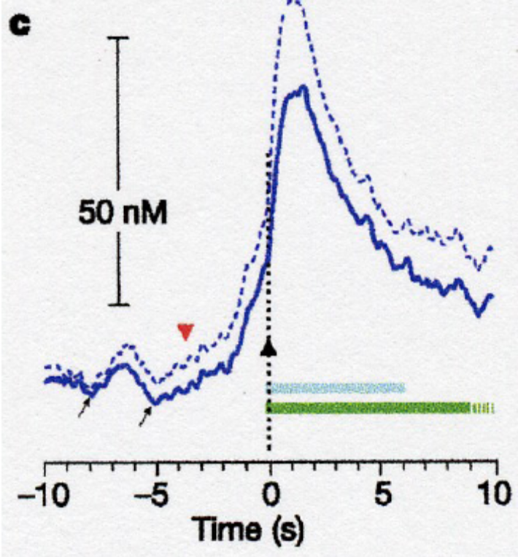
DA Signal during Approach to Cocaine:
- the initial bump between -7s and -6s is when the mouse is debating about whether to go and get another hit
- the large bump just after the 0s is the DA signal when the animal is definitely approaching the drug
- the drive towards the drug is what is driving the DA signal
- but this does not show if the approach is stimulated by DA levels (meaning that we are wondering if the levels of DA trigger the desire to have more)
The second graph that I have not added conveys that when we electrically stimulate the release of DA, this causes the mouse to go and press the bar. So an increase in DA firing makes the animals go get another hit of the drug (cocaine).

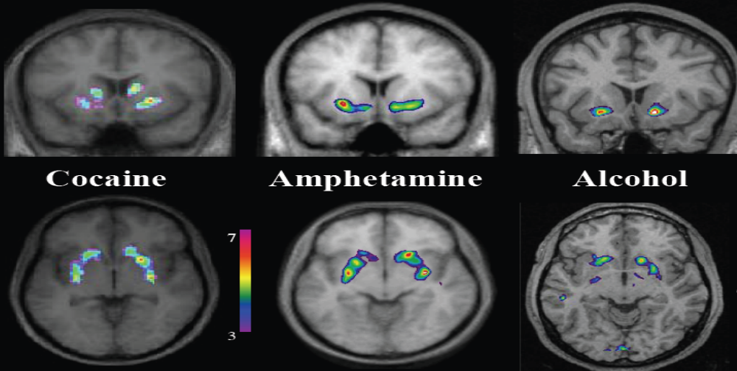
The highlighted sections show the regions where there are significant changes in extracellular DA levels.
Cocaine, amphetamines and alcohol increase the extracellular DA levels in the ventral striatum, the region that corresponds most closely to limbic striatum, or NAc in primates.
Nicotine-Induced DA Release
This study involved splitting a group of smokers into two groups. Each group got 2 scans. In one group, both scans were without prior smoking, and in the other group one scan was without any prior smoking and the other scan was with prior smoking.
    - smoking cigarettes increased DA level with the largest effects in the ventrical striatum
    - gene changes: the gene encoding D4 receptor, which increased DA release. People with higher D4 activity have a larger DA increase – smokers with a lot of D4 receptors are the people who genetically tend towards being life smokers because smoking is more pleasurable to them
    - nicotine seems to potently enhance DA firing, but it does not stimulate DA release
    - COMT breaks down DA. COMT activity is associated with lower tonic DA levels

Effects of Repeat Stimulant Drug Administration: Sensitization
What changes with repeated drug exposure? Sensitization!
    - DA response gets progressively larger with every hit
    - Repeated exposure to abuse drugs leads to progressive increases in their ability to increase extracellular DA levels
    - This is not a purely pharmacological effect, but if the drug is repeatedly taken in a specific place, or environment, they will NOT show the sensitization effect if they get a hit in another environment
    - Sensitization is also accompanied by a progressive increase in the animals’ willingness to work hard to get the drug
    - Time in between the drug exposures has no effect on sensitization. If a week/year pass between drug doses, sensitization is still observed
    - there are many figures in the class notes that show the increased DA signal due to sensitization
Does sensitization happen in humans?
The biggest criticism involving sensitization is whether it is actually observed in humans. Although, Dr. Leyton did show a graph where sensitization was conclusive in humans. The problem is that there is no real way to be sure that the patients did not use the substance in between clinical exposures. BUT a student in class mentioned that even if they did abuse outside of the study, this would not have an effect on the study due to sensitization-environment pairing. So, yes, sensitization does happen in humans.

